How to Recover Access to Your EC2 Instance After Losing the Private Key

Author: MahendraKumar V
LinkedIn: https://www.linkedin.com/in/mahendra-kumar-v/
Role: Cloud Engineer

There is two types of keys:
Public Key
Private Key
.pem key called Private key which is stored in cryptographic keys and certificate.
In aws generally refer to a private key file used to securely access ssh Ec2 instance.
Private key files donwloaded and stored in local machine, This is secrete key file, Only you should have access to this file, You can securely access Ec2 instance using this key.
Public key: This key stored in Ec2 instance, which is used to verify the identity of anyone connecting to the instance with the correspondent private key.

Private key -> Local Machine
Public Key -> Ec2 Instance

Ssh Connection send a connection request to Ec2 instance, The Ec2 instance uses a public key to verify the request, If matches access is granted.
Step-by-Step Process for Recovering a .pem File
If once you lost your key pair you can’t get in back from the aws because aws does n’t get backup, But still you can access Ec2 instance.

Stop Ec2 Instance -> Detach root Ebc Volume from Ec2 Instance -> Attach Ebs Volume from another Ec2 instance -> Access the file system -> Check the volume -> Modify the Authorised Key -> Re Attach the Ebs Volume to Original Ec2 Instance -> Start Ec2 Instance.

Stop Ec2 Instance:
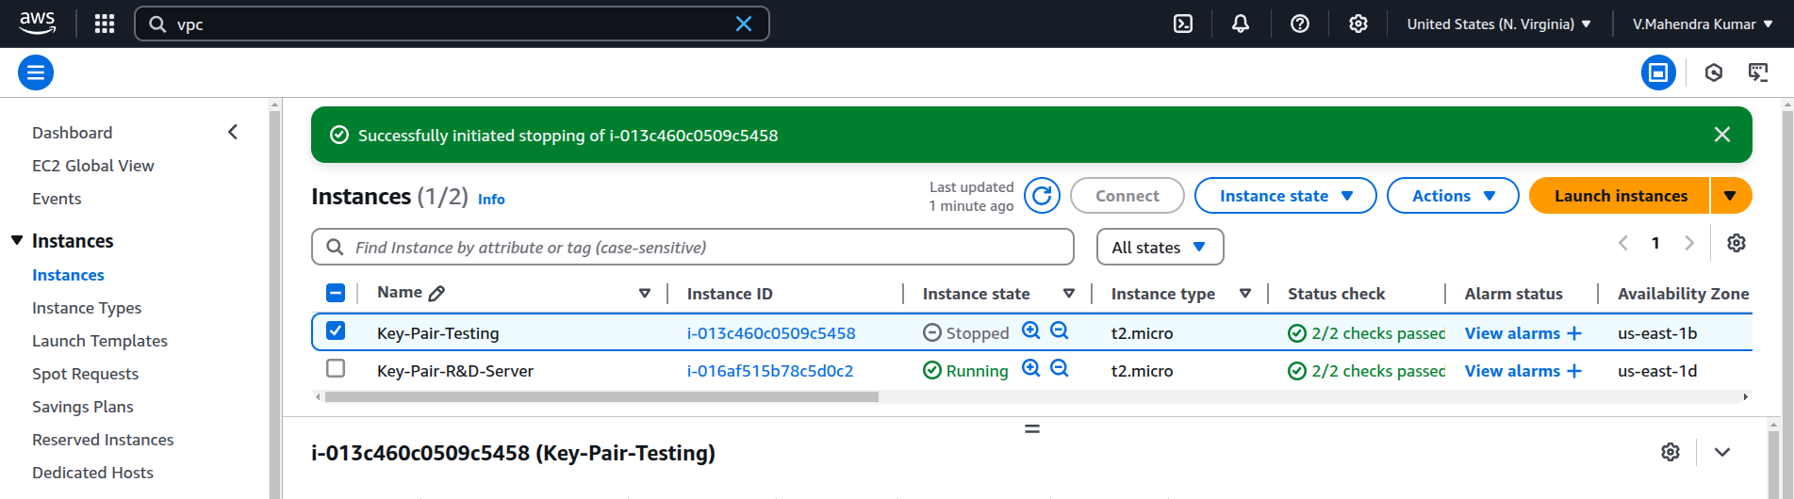

Detach Ebs Volume :
The Go to Volume -> Actions -> Detach Volume
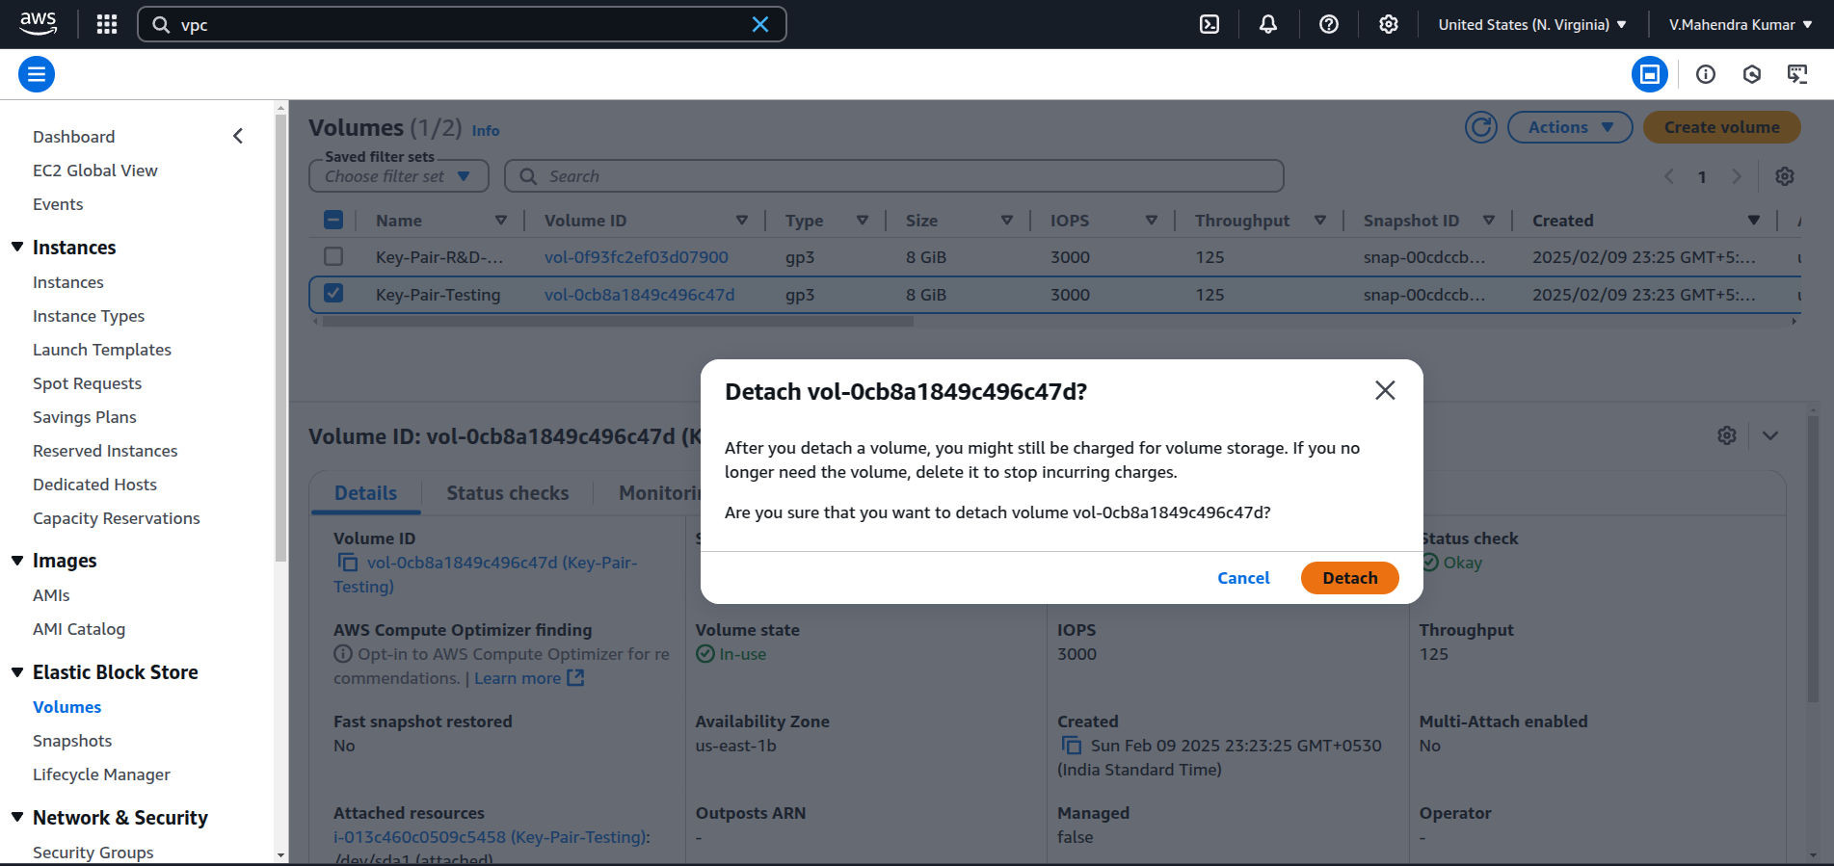
Then Go to instance and select stopped instance Block Device status
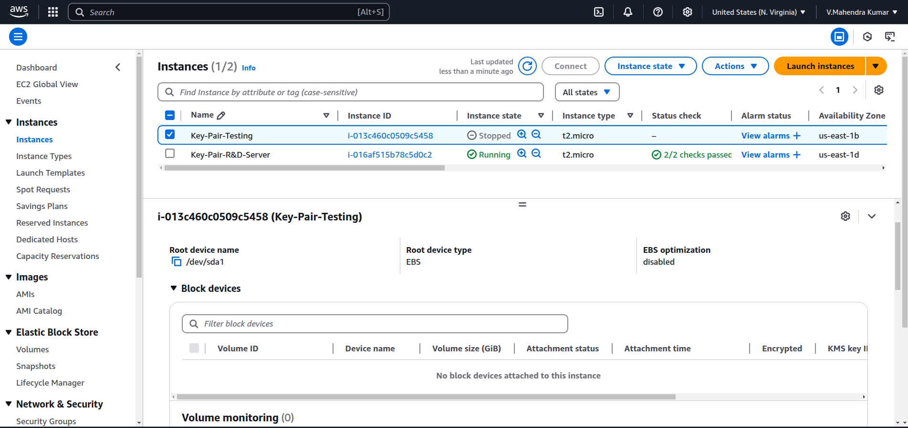
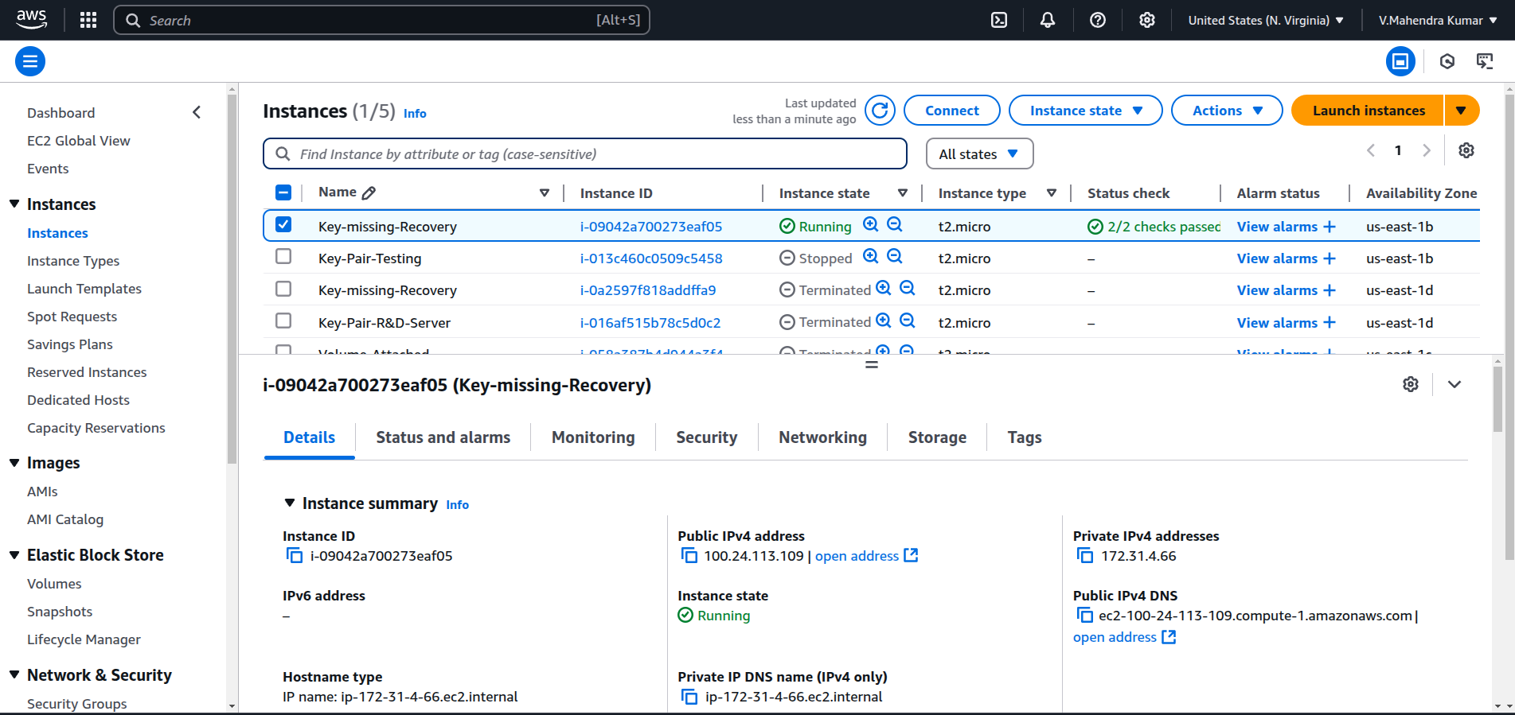
Launch Seconday Ec2 instance that should be in same availablity zone:
Attach Ebs Volume to Secondary Ec2 instance
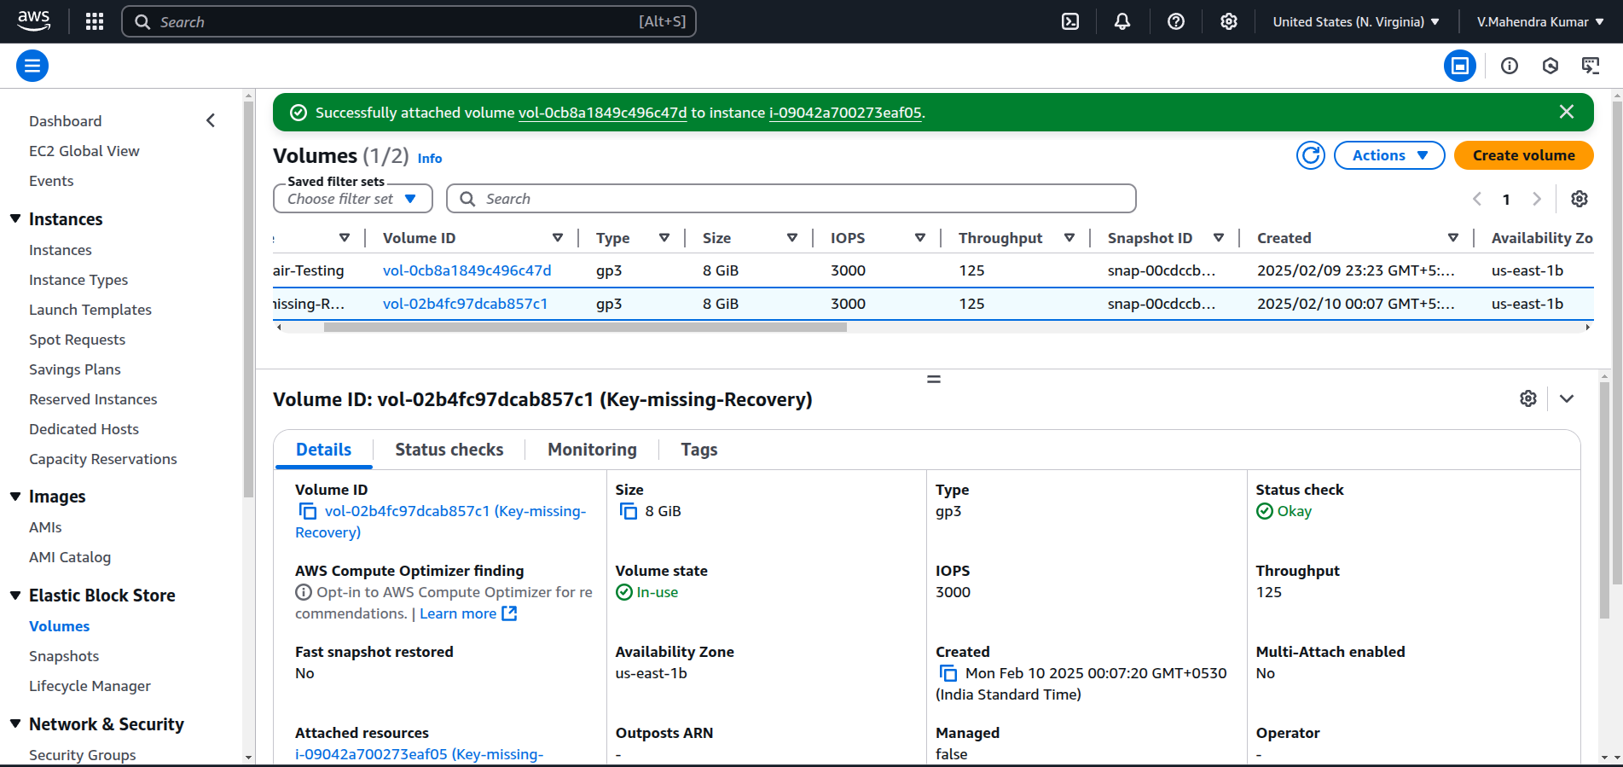
Login to verify attached EBS volumes are availabe or not
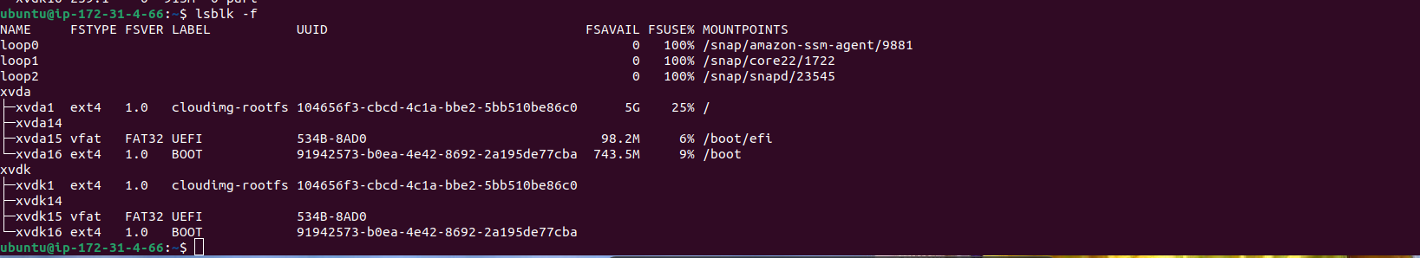
Create a new directory for mount point (root@ip-172-31-44-184:~# sudo mount /dev/xvdk1 /home/ubuntu/xvdr/)

Step1: root@ip-172-31-44-184:~# mkdir -p /home/ubuntu/xvdr
Step2 : sudo mount /dev/xvdk1 /home/ubuntu/xvdr/)
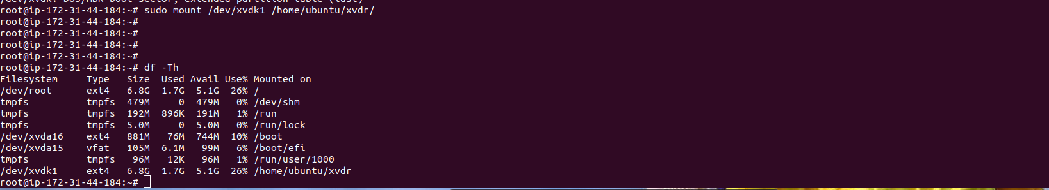
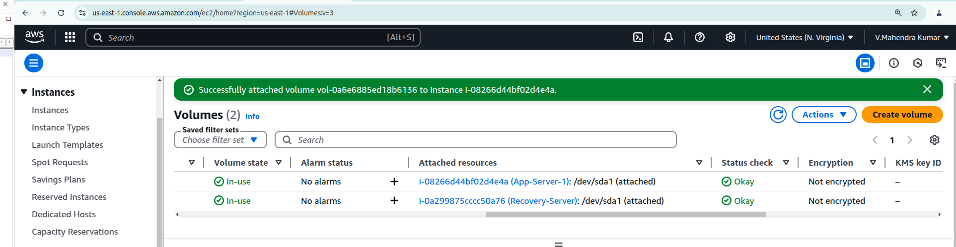

Reattached and started App-server-1 (Primary Instance)
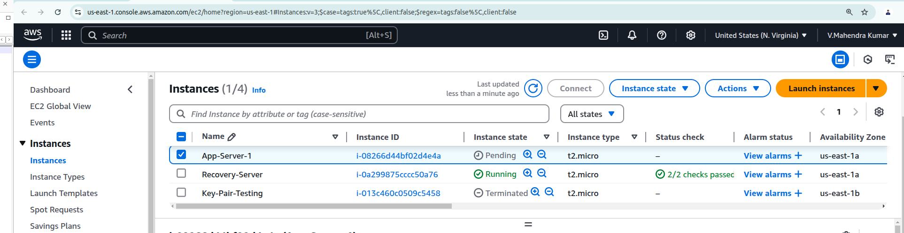
Final output

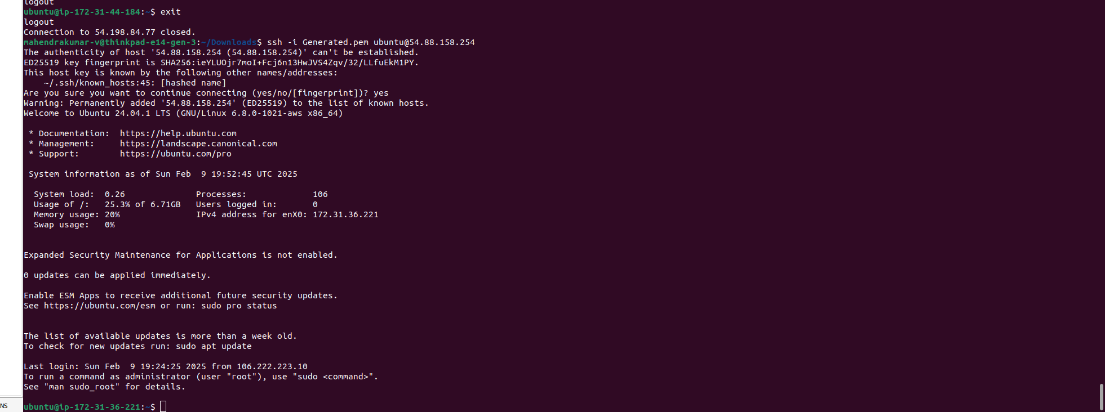
All The Best !!

